Indian Institute of Information Technology, Vadodara

College HR Management and Payroll System

Draft User Manual

CS301 Software Engineering Project – Autumn 2015

team #02 - ninEngineers

team #02 – ninEngineers:
Sr. No | Roll No. | Name
01. | 201351005 | Abhijit Singh Panwar
02. | 201351006 | Yash Choubey
03. | 201351017 | Rahul Nalawade
04. | 201351021 | Manu Sharma
05. | 201351023 | Murtuza Bohra
06. | 201351024 | Shalinee Singh
07. | 201351030 | Ajay Shewale
08. | 201352006 | Nitin Kumar Singh
09. | 201352013 | Sameer Bhati

Author/ Reviewer:
Author/ Reviewer | New Version | Date
Ajay Shewale | v1.0 | 12th September 2015
Sameer Bhati | v1.1 | 17th October 2015
Shalinee Singh | v1.2 | 16th November 2015

Abstract
Our system provides a solution for the HR management and the payroll system. This document explains the basic functionality of the system to help the user to grasp the idea and functioning of the system. The permissions and rights of each kind of user is well defined in the document to provide an overview of the working of the system.

Contents
- Introduction
1.1 Intended Readership
1.2 Applicability
1.3 Purpose
- Overview
- Getting Started
3.1 Access
3.2 System Structure
3.3 Logging In
- HR Admin
4.1 Add New Employee
4.2 Loan Records
4.3 Leave Records
4.4 Salary Component Details
4.5 Employee Profile
4.6 Increments/ Promotions/ Overtime
4.7 Investments/ Recovery/ Penalty
4.8 Bonus
4.9 Remove Employee
4.10 Change Password
4.11 Logout
- Accountant
5.1 Leaves Accepted
5.2 Loans Accepted
5.3 Generate Payslips
5.4 Generate Bank Payslips
5.5 Change Password
5.6 Logout
- Employee
6.1 Leave Account
6.2 Loan Account
6.3 Update Profile
6.4 Logout

1. Introduction

1.1 Intended readership
This document covers the use for the following users of the HR management and Payroll system:
- Administration of HR department
- Accountant
- Employees

1.2 Applicability
This Software User Manual applies to the HR management and Payroll System software, version 1.0.
1.3 Purpose

The purpose of the User Manual is to guide the user in the better understanding of the system.

2. Overview

Assistance and ease of the workload of the administrative staff of the Indian Institute of
Information Technology, Vadodara (IIITV) is the main goal of the software solution we are providing.
A user friendly quality product is our top priority throughout this development. This is a comprehensive system with customizable parameters to compute various pays and salaries through web application. It can also keep a close check on efficient data manipulation, data security with a simple design and elegant user-interface.
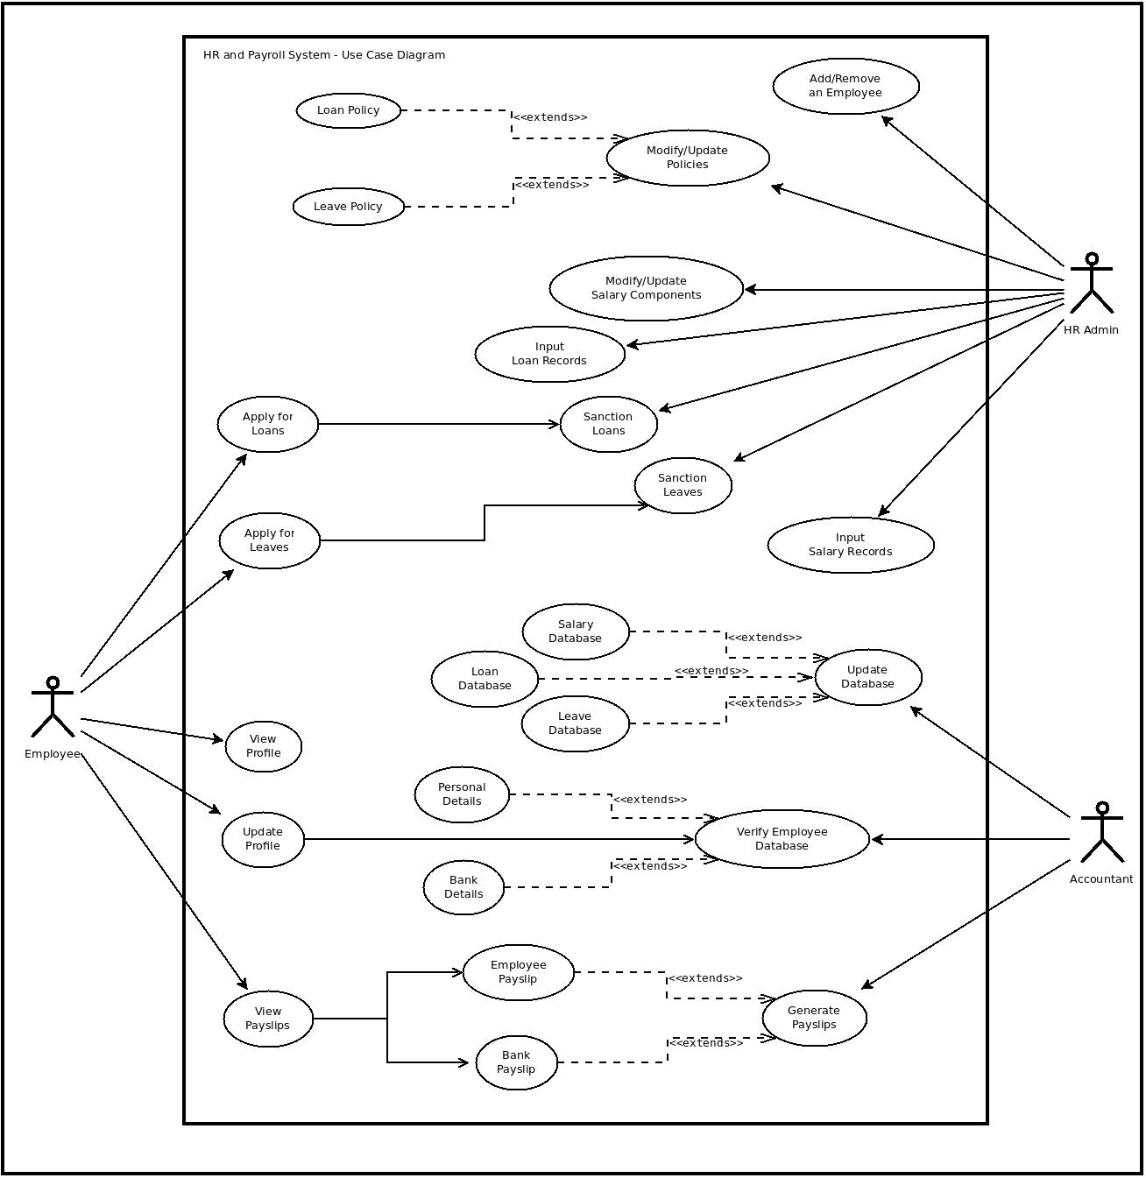Use Case Diagram
3. Getting Started
The section provides a general walk through of the system from start to end. The arrangement of the information will help to understand the flow of the system.
3.1 Access
Access the portal through ______
3.2 System Structure

The system is divided into three modules:
- HR Admin
- Accountant
- Employee

Different kinds of rights are provided to different kinds of users.

3.3 Logging In
After getting access to the portal, the user sees a login page.

- An employee can log in the system using employee ID. When an employee sign up for the first time, an email will be sent to his/her mail ID with the password generated by the system. Employee can now log in using the employee ID and the password.
- The HR admin and the accountant will be provided with a login ID and a password. They can access the system using there ID and password.

If user forgets the password, he/she can request a new password by clicking on the Forgot Password link. A mail will be sent to his/her registered email id with the new system generated password.

Once the login is successful, the user will be redirected to the respective pages according to the rights given to them.

By default, the username and passwords are:
Admin: username - 2, password - pswd2

Accountant: username - 1, password – pswd3

Employee: username - 1001, password - p1

4. HR Admin
The following services are provided to the Admin of the Human Resource:
The admin can check details of the employee by entering the name or ID of the employee. He'll get all the relevant details about the employee.
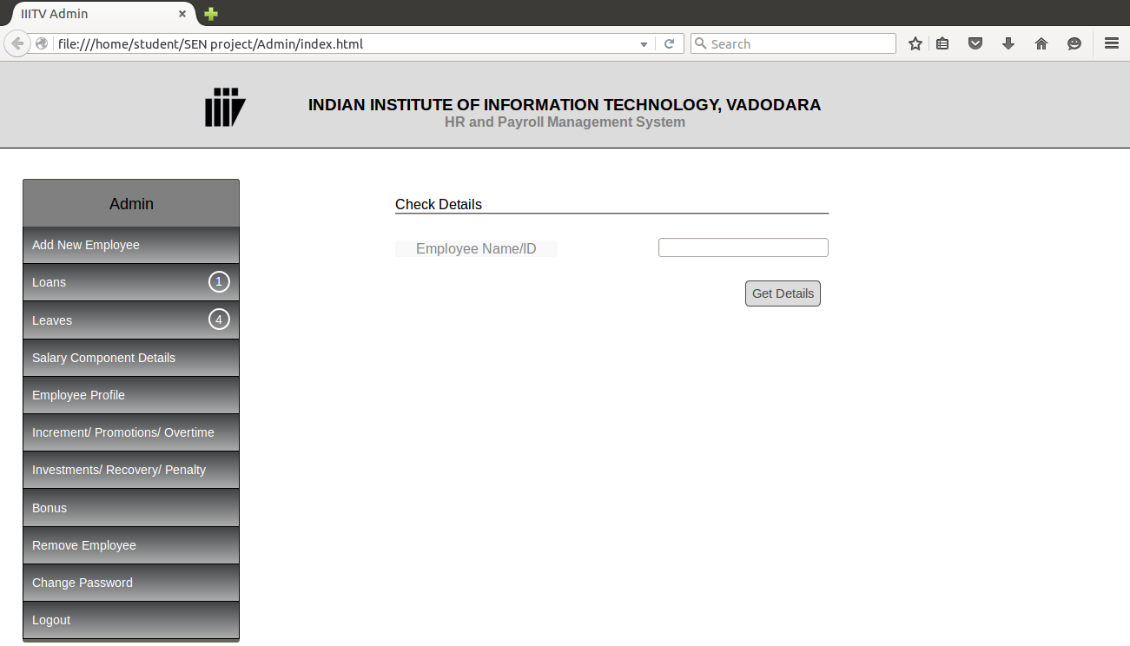
4.1 Add new Employee
When a new employee recruited in the institute, the Admin can add his/her records to the existing database. These are the details the Admin needs to mention when adding a new employee:

- Personal Details
  - Full Name
  - Address
  - Date of Birth
  - Phone1
  - Phone2
  - Email ID
  - Aadhar Number
  - Emergency Contact Details
    - Name
    - Address
    - Phone1
    - Phone2
    - Relationship
- Official Details
  - Employee ID
  - Designation
  - PAN No.
  - Official Email
  - Date of Joining
  - Experience (Years)
- Bank Details
  - Name of the bank
  - Branch
  - Address
  - IFSC Code
  - Account Holder's Name
  - Account Number

After providing the necessary details, the employee can be made a part of the payroll system by clicking on the 'Save and Add Employee' button in the Bank Details tab.

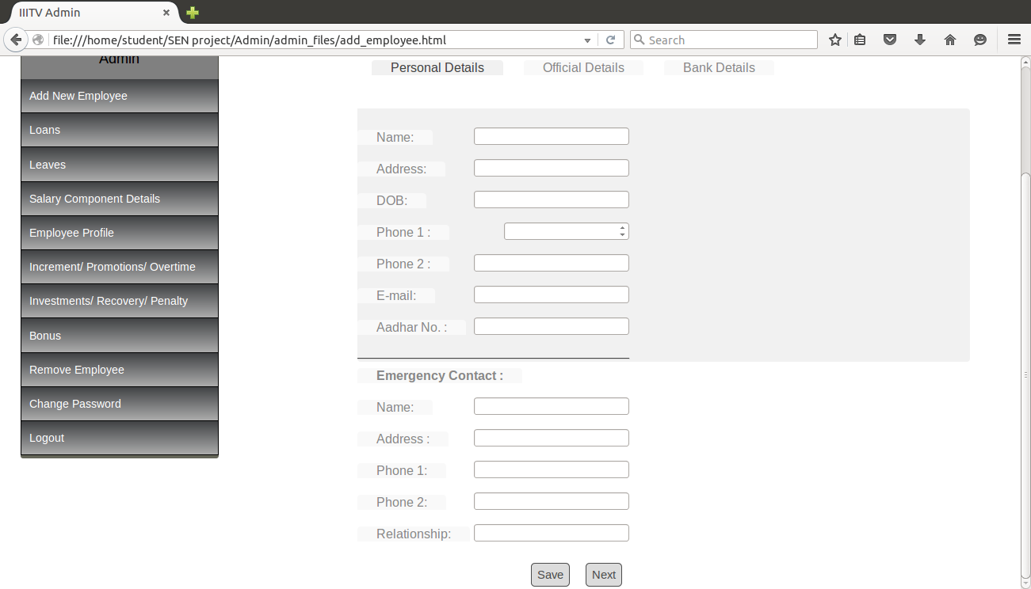

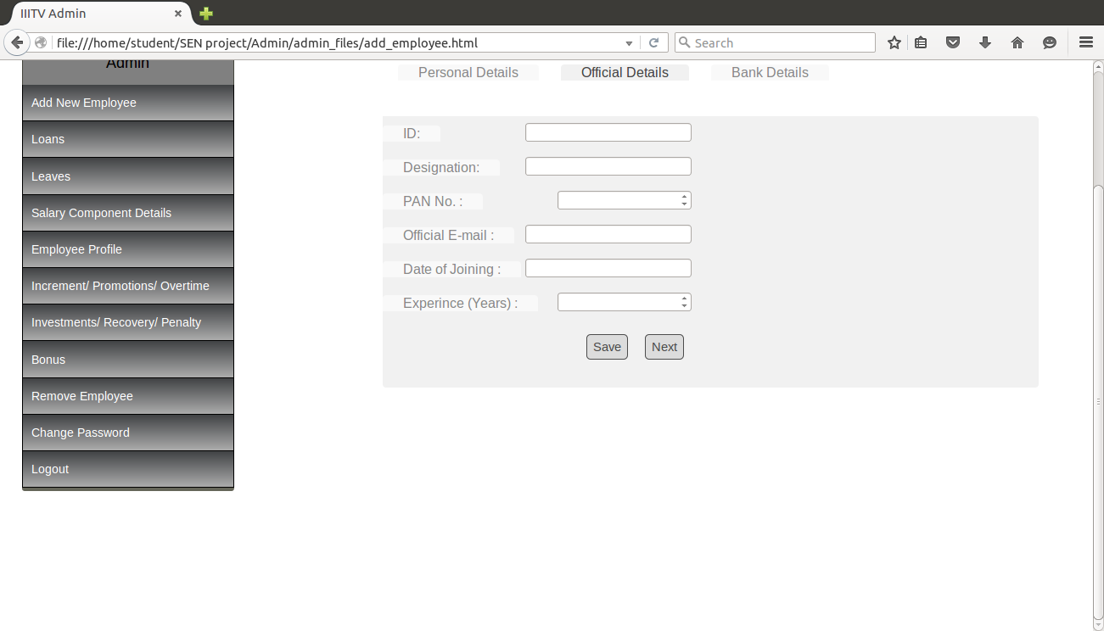
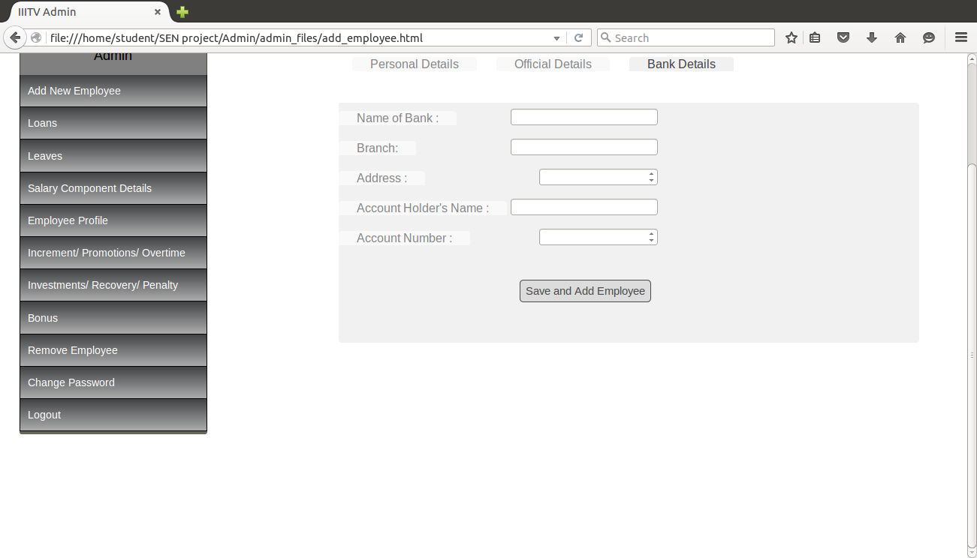
4.2 Loan Records
When an employee applies for a loan, a request is received by the Admin. Admin can grant the loan or reject it. The total loans can be categorized in two categories:
- Pending Requests
Whenever any employee applies for a loan, the Admin gets a notification of the same. Admin can see the details of the request and take the decision accordingly whether to grant the request or reject it.
Loan applications can be seen here.
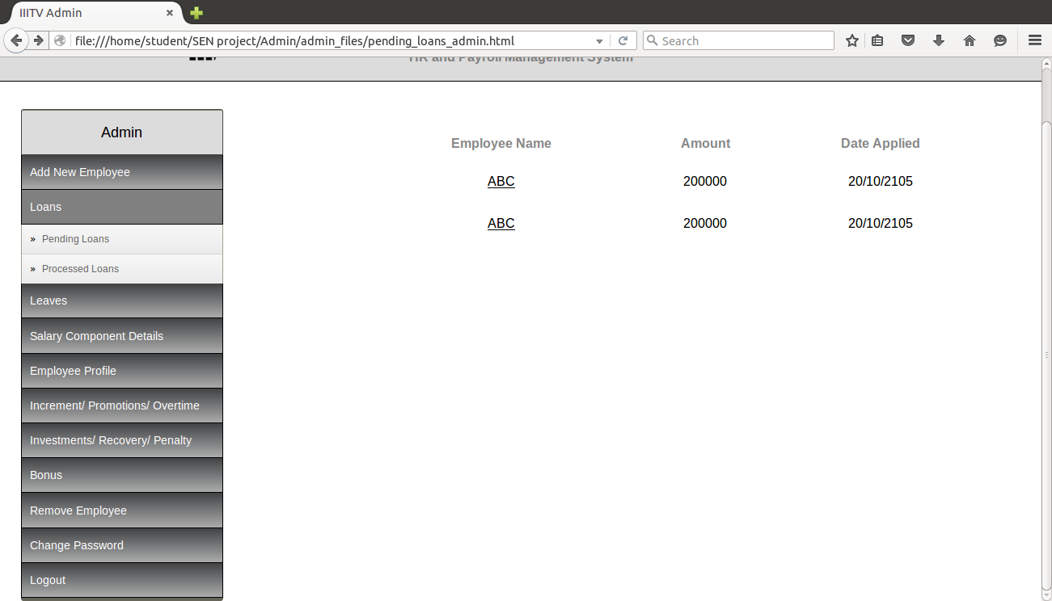
By clicking on the name of the employee, the details can be see. It can be accepted by clicking on the 'Accept' button and rejected by clicking on the 'Reject' button. A confirmation box will open. Enter the reason for rejection (if any) and click reject to confirm rejection.
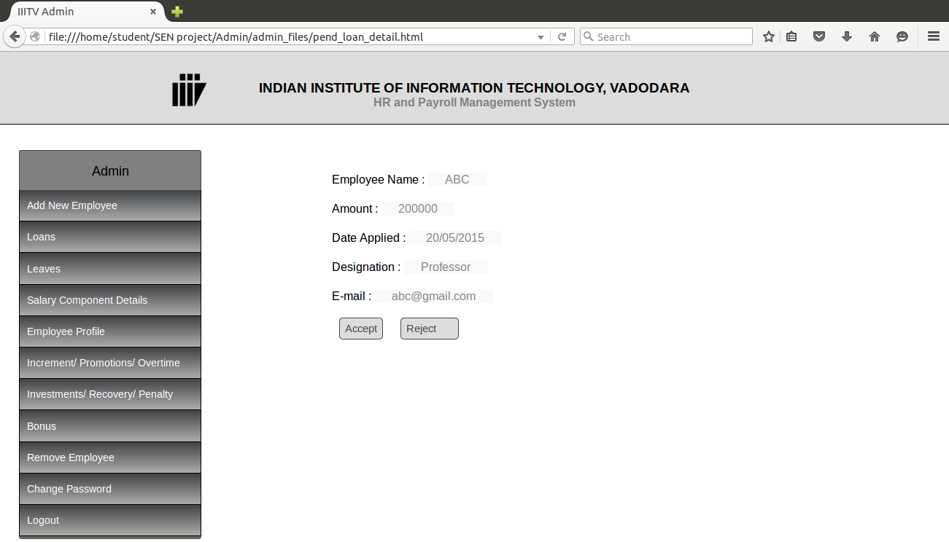
- Processed Requests

In this section the details of all the previous loan applications whether sanctioned or rejected can be seen. The Admin can keep a track of all the loan related activities.
A list of applicants appear, and by clicking on the name of the applicant, the details can be viewed.

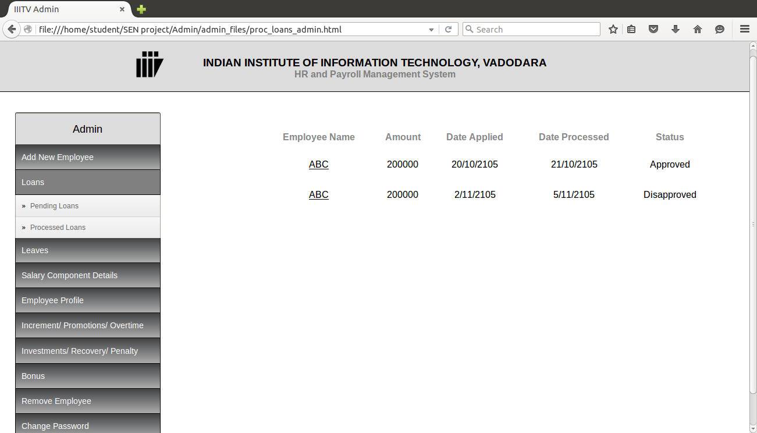

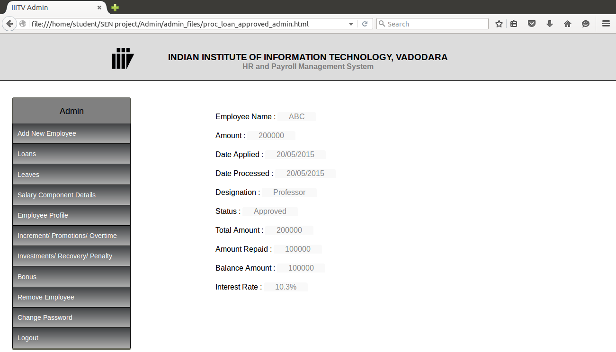

4.3 Leave Records
- Non-paid leaves

When an employee takes a leave without providing prior information, this kind of leave is counted here. Then the information is passed on to the accountant for further processing. The admin has to enter the employee name/ID and the dates on which he has taken the leave without informing. On clicking the 'Update' button, the request is forwarded to the accountant.
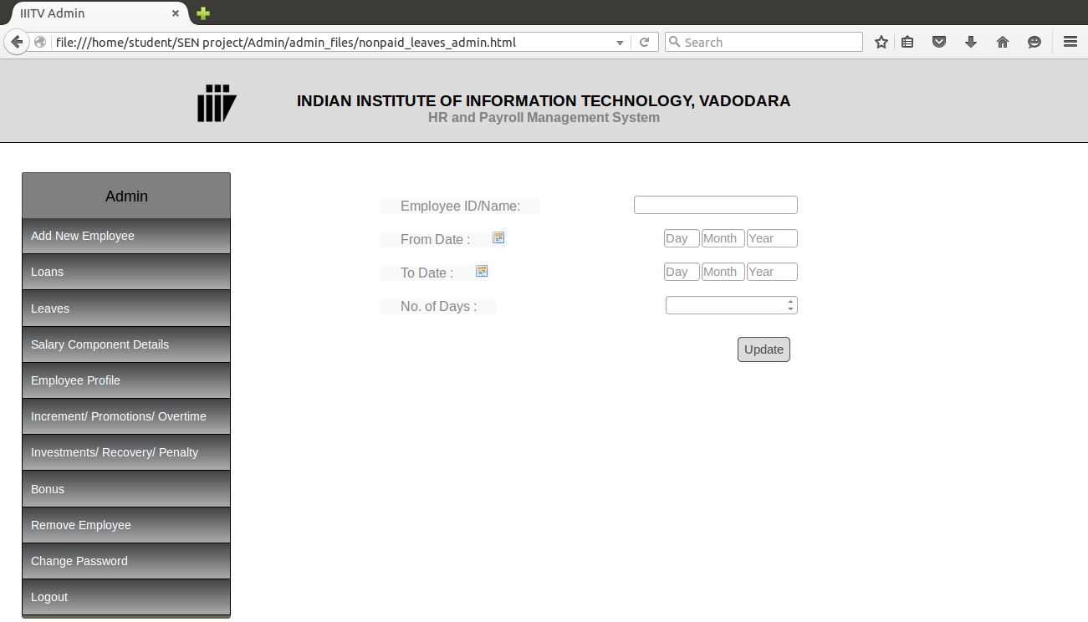
- Pending Requests

Whenever any employee applies for a leave, the Admin gets a notification of the same. Admin can see the details of the request and take the decision accordingly whether to grant the request or reject it.
A list of pending leaves appear. On clicking on the employee's name, details of the application can be seen and the decision can be taken accordingly.

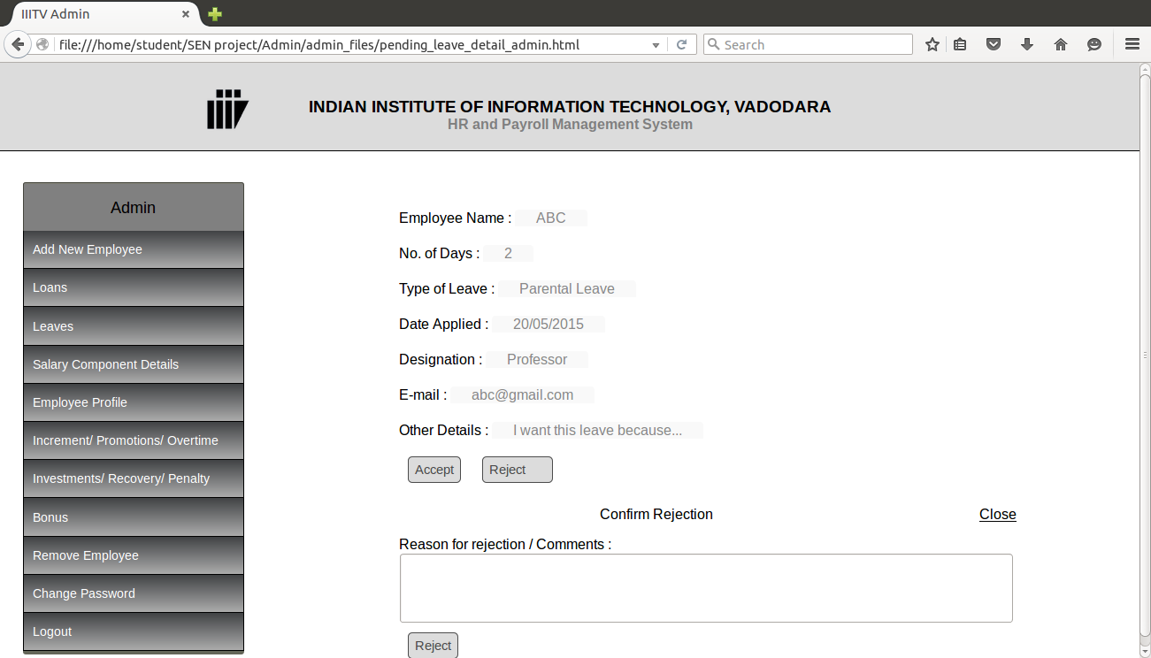

- Processed Requests

The details of all the previous leave applications, whether granted or rejected can be seen. The Admin can keep a track of all the leave related activities, which employee has taken leave of how many days and of which category.
A list of applicants can be seen, and by clicking on the name of the applicant, the details can be viewed.

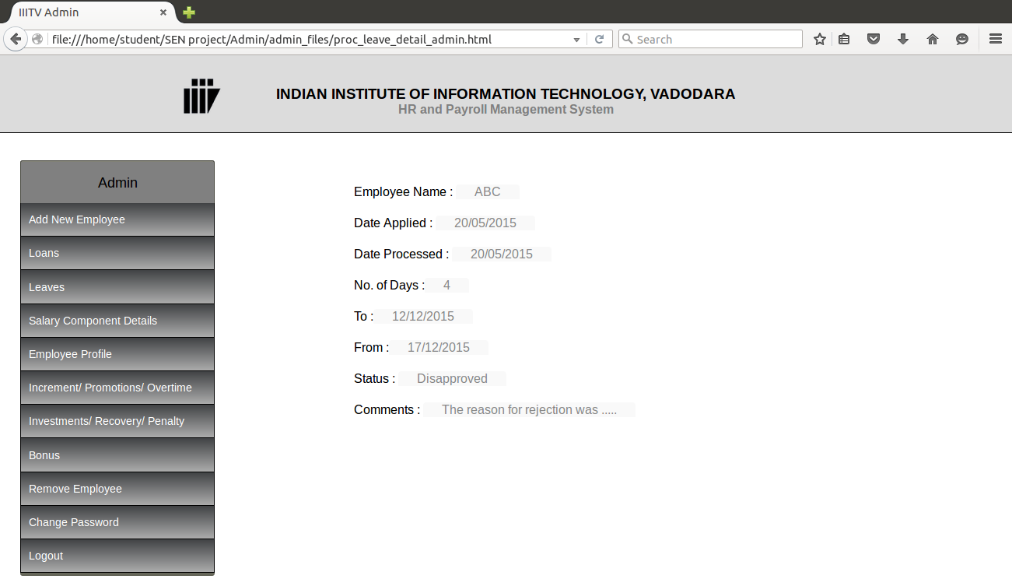

4.4 Salary Component Details
The Admin can modify the percentages of different allowances or deductions of the salary of the employees. Once the changes are made here, the new salary that will be computed after the modification, will be computed on the basis of the modified values.
The components that can be modified by the admin are
- DA (Dearness Allowance)
- HRA (House Rent Allowance)
- Transport Allowance
- DA on TA
- CPF (Central Provident Fund)
- GPF (general Provident Fund)
- Licence Fee
- Pay and Allow (Recovery of erroneous payments)
- Profession Tax
- Revenue Stamp

The admin can enter the new values for these components and click on 'Update Policy' to chnage the policy for all the employees.
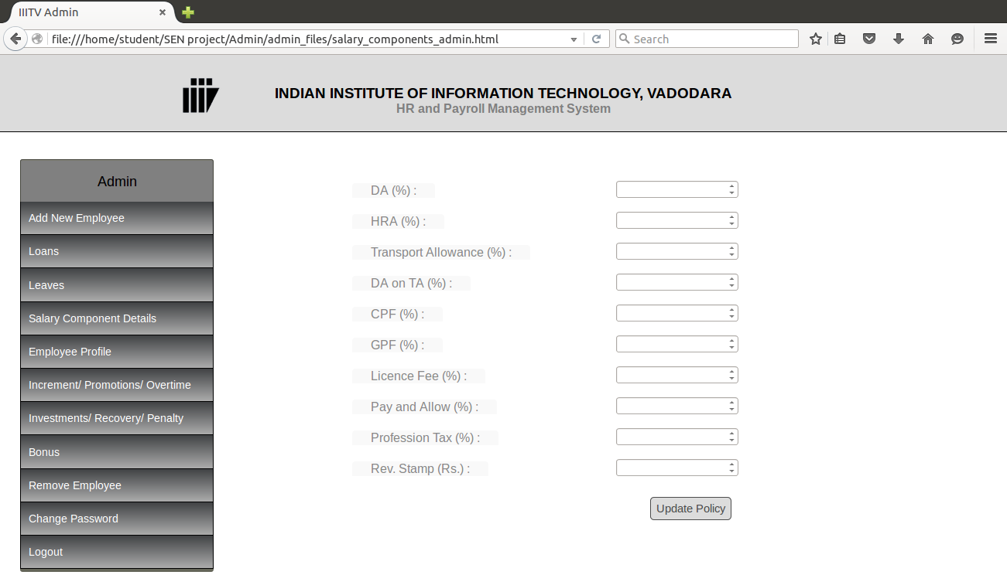
4.5 Employee Profile
The details of all the employees can be seen here. Employees personal, official and bank details as well as current leave and loan status can be monitored. The list of employees is sorted by their designations. By clicking on the designation list on the left side of the window, only the employees of that designation can be seen. By clicking on the name of the employee, all the details of that employee can be seen, his personal, official and bank details, his leaves and loans details, his salary details, penalty and bonus.
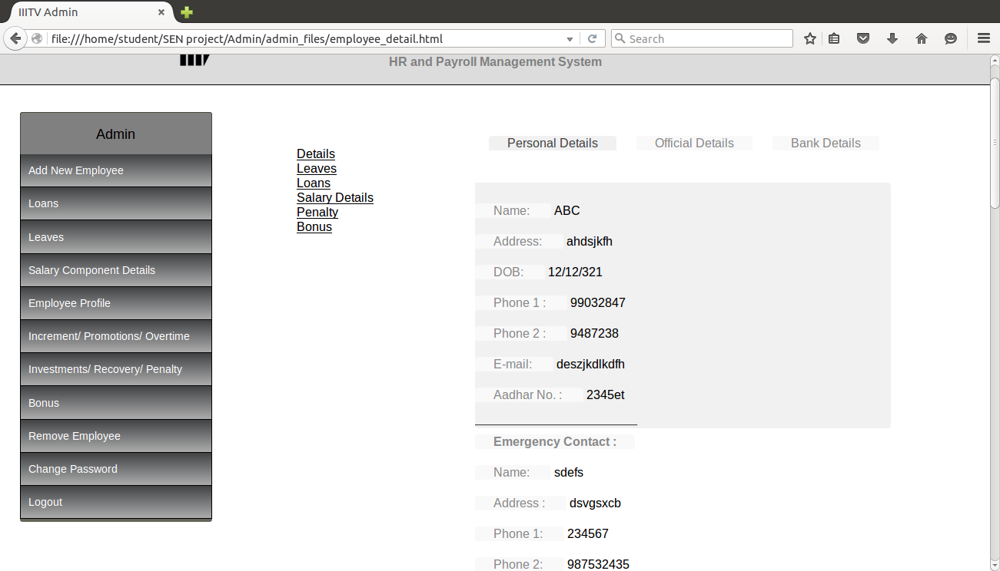
4.6 Increments/ Promotions/ Overtime
The Admin can add the increments given to the employees by entering the employee ID, percentage increment and the details of the increment. On clicking the 'Add Increment' button, the updates will be saved.
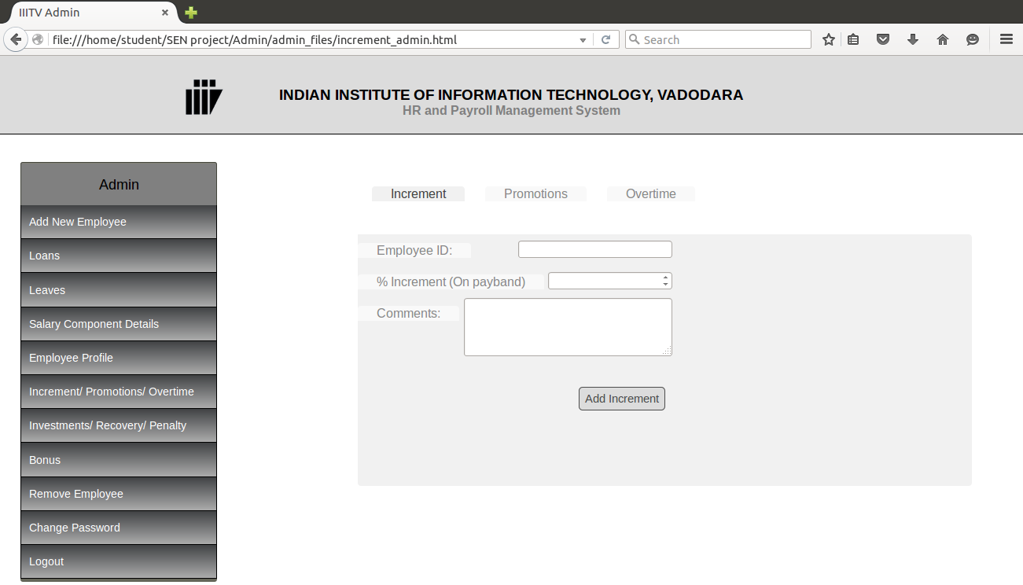
The Admin update promotions given to the employees by entering the employee ID, percentage increment on basic salary and the comments on the promotion(if any). On clicking the 'Update Status' button, the updates will be saved.
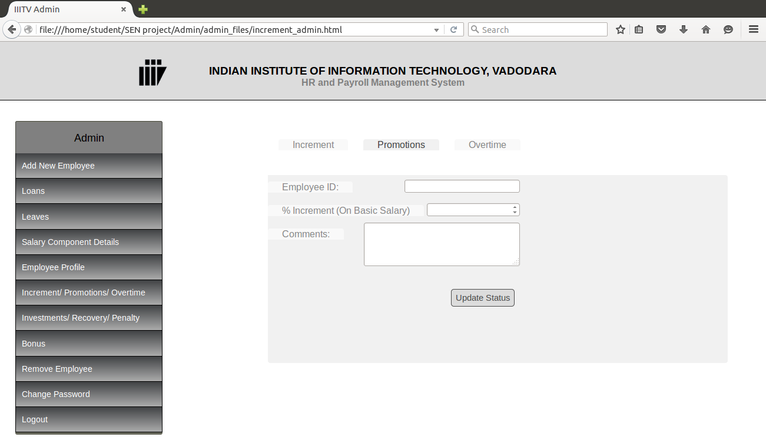
The Admin update overtime done by the employees by entering the employee ID, starting date, end date, effective no of days(number of days whose salary is to be paid; can be in fraction also), total amount to be paid and the details of the overtime(if any). On clicking the 'Add Overtime' button, the updates will be saved.
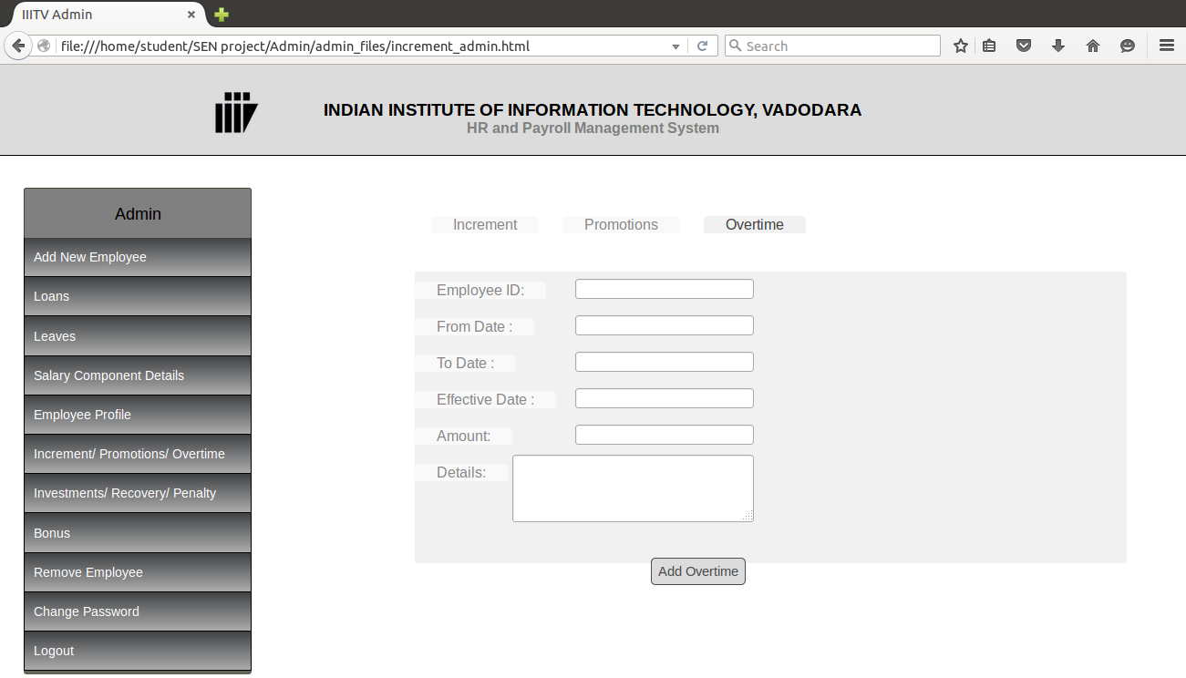
4.7 Investments/ Recovery/ Penalty

The Admin can add the investments made by the employees by entering the employee ID, from date, to date, investment no, monthly amount and the details of the increment(if any). On clicking the 'Add Investment' button, the updates will be saved.
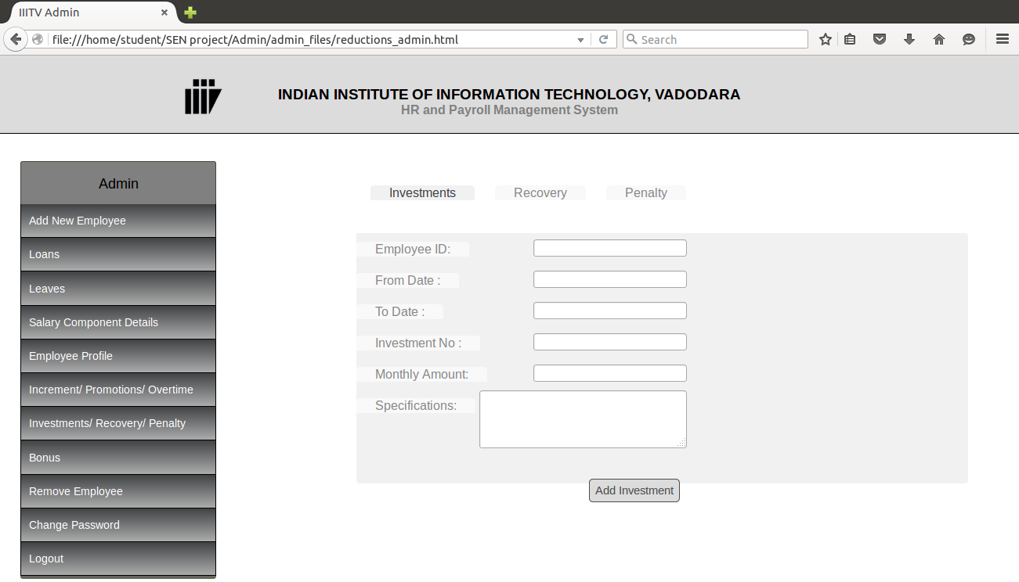
The Admin can add the recovery details of the loan or advance taken by the employees by entering the employee ID, from date, to date, loan or advance number, monthly amount and the details of the recovery(if any). On clicking the 'Add Recovery' button, the updates will be saved.
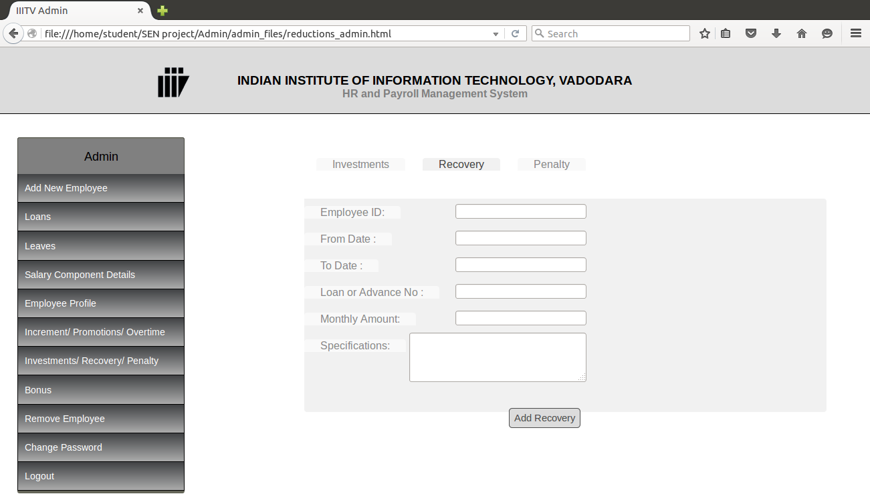
The Admin can add the penalty details(in case of disciplinary actions) of the employees by entering the employee ID, date, penalty number, amount and the details of the penalty(if any). On clicking the 'Update Penalty' button, the updates will be saved.
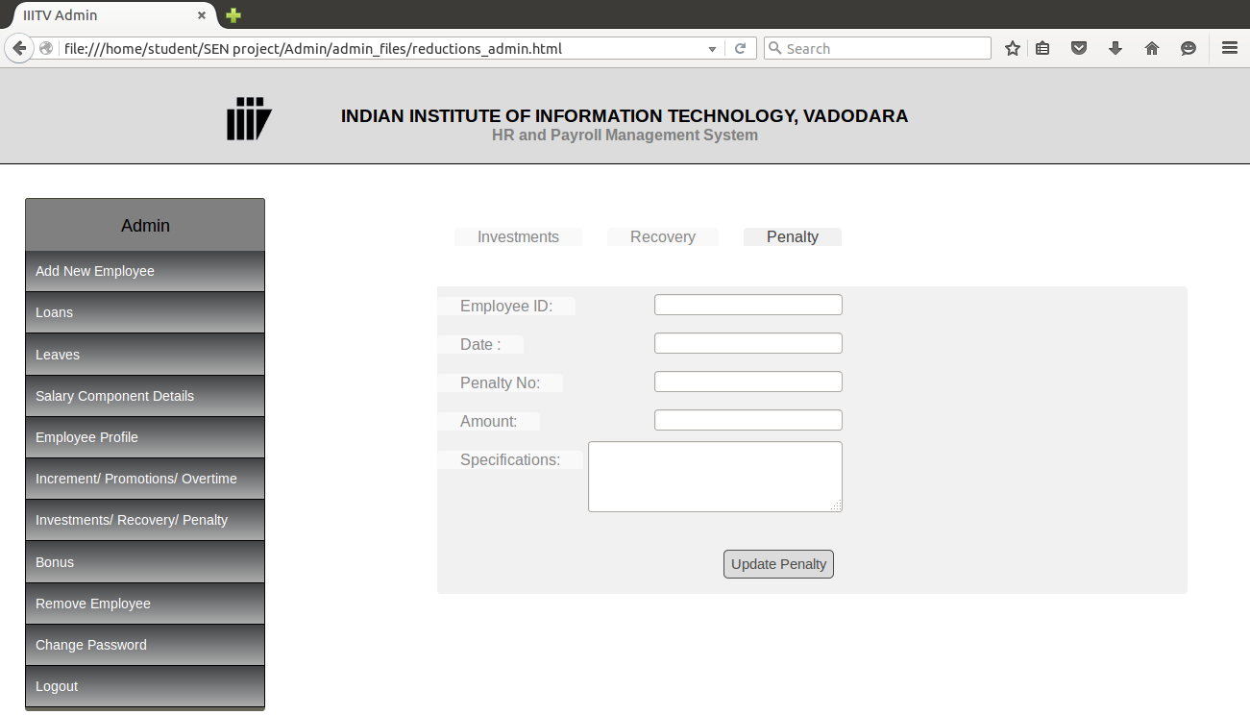
4.8 Bonus
The Admin can add the bonus details (when bonus is granted by the organization) of the employees by entering the employee ID, date, amount and the details of the bonus(if any). On clicking the 'Add Bonus' button, the updates will be saved.
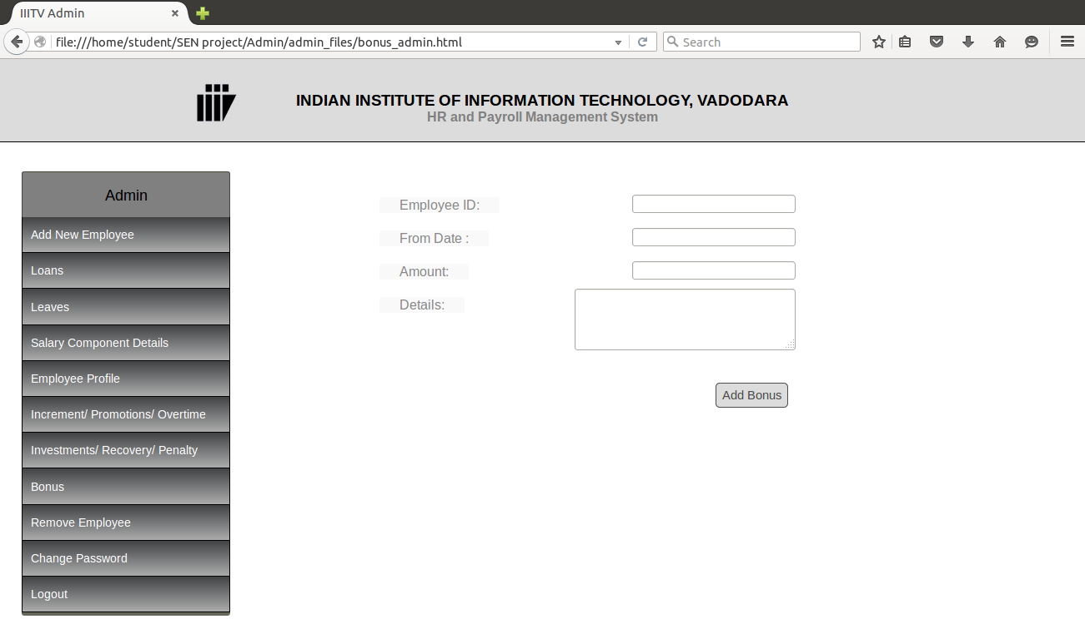
4.9 Remove Employee
When an employee leaves the institute, his/her salary calculation should be ceased. In order to do so, the Admin can remove the name of the employee from the list of the current employees. This will not delete the previous data of the employee but only stop the further salary calculations of the employee. The Admin can remove the employee by entering the employee ID, employee name and the date of termination. On clicking the 'Remove Employee' button, the employee will be removed.
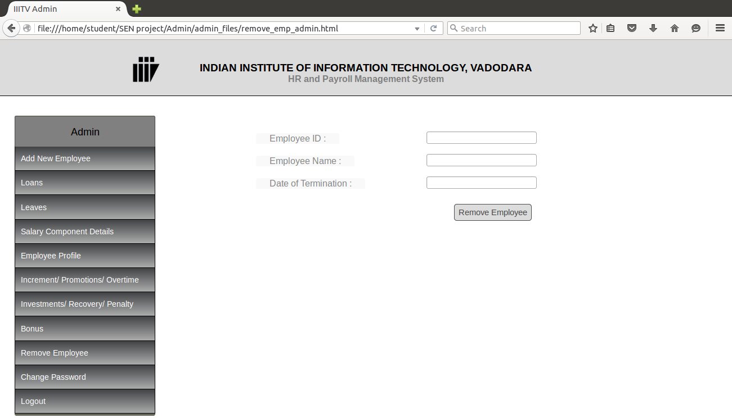
4.10 Change Password
For general security reasons, admin may periodically change login password. The admin need to provide current password for validation purpose if it is not correct, the system will not process the request to change the password. This check is to protect current user’s confidentiality. The Admin can enter his old password, then a new password and confirm the new password by entering it again. On clicking the 'Update Password' button, the password will be updated.

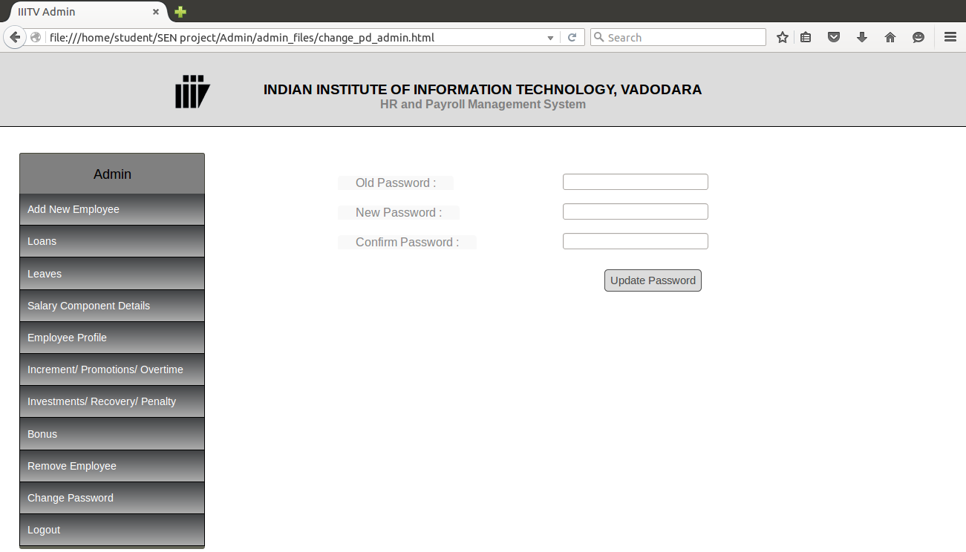
4.11 Logout
To exit from the system click on the Logout option.

5. Accountant
5.1 Leaves Accepted
Once the leave of an employee is accepted by the HR admin, a notification is received by the Accountant. Accountant can update the leave record of the employee accordingly. When the leave record is updated, the salary is calculated on the basis of the new details.
The leaves that are already updated are marked as 'Seen' and those which need to be updated are marked 'Unseen'. By clicking on the employee's name, the details of the application can be seen. If the leave is unseen, then by clicking on the 'Update Profile' option, the details can be updated in the employee's account, or else the data is visible without any update option.
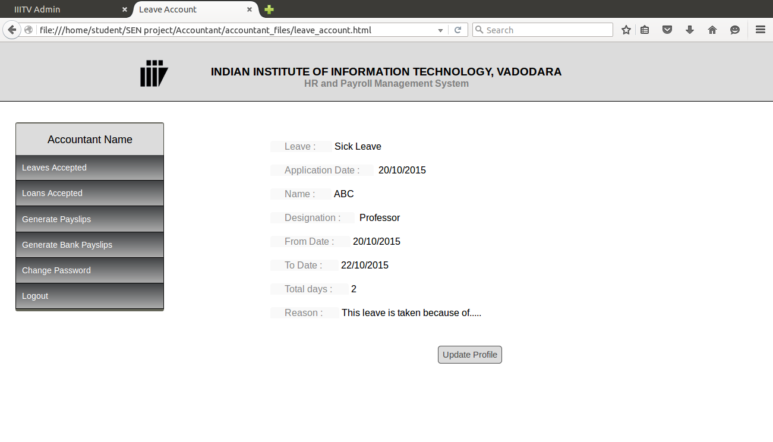
5.2 Loans Accepted
When the HR Admin accepts a loan request, a notification is received by the Accountant. Accountant updates the loan account of the employee. Monthly instalments are calculated on the basis of the amount of the loan and the duration for which it is taken. The amount is deducted from the employee's salary while generating the monthly payslip.
The loans that are already updated are marked as 'Seen' and those which need to be updated are marked 'Unseen'. By clicking on the employee's name, the details of the application can be seen. If the loan is unseen, then by clicking on the 'Update Profile' option, the details can be updated in the employee's account, or else the data is visible without any update option.
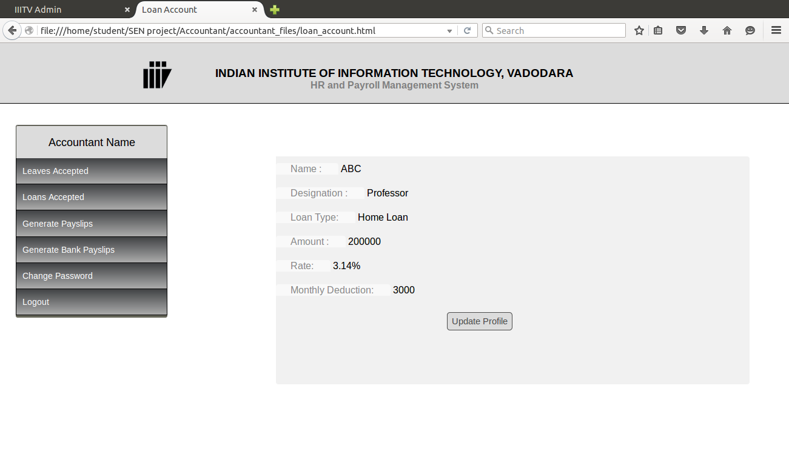
5.3 Generate Payslips
The Accountant can generate the payslips of all the employees at once. At the end of the month, the payslips of all the employees can be generated and they can be informed by a mail that will be sent to their mail ids with the details of the payslip. The list of all the employees can be seen with the names of the employees, their Ids, designations and the net amount that is to be paid. By clicking on the 'Generate' button, a pdf will be generated with the details shown on the screen.
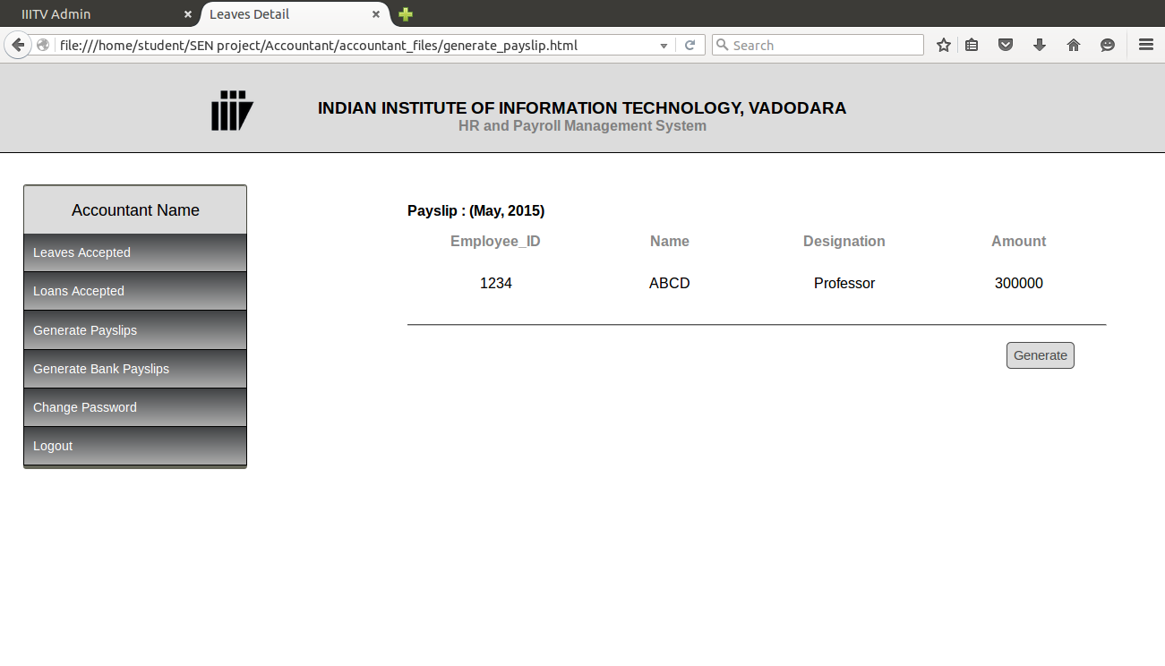
5.4 Generate Bank Payslips
After transferring the amount to the employee’s bank accounts, a payslip can be generated as a proof of the payment made by the institute. The bank payslip will contain the transaction number along with the details of the employee. The list of all the employees can be seen with the names of the employees, their Ids, account number, IFSC Code, Branch name and the net amount that is to be paid. By clicking on the 'Generate' button, a pdf will be generated with the details shown on the screen, so that it could be sent to the bank for payment accordingly.
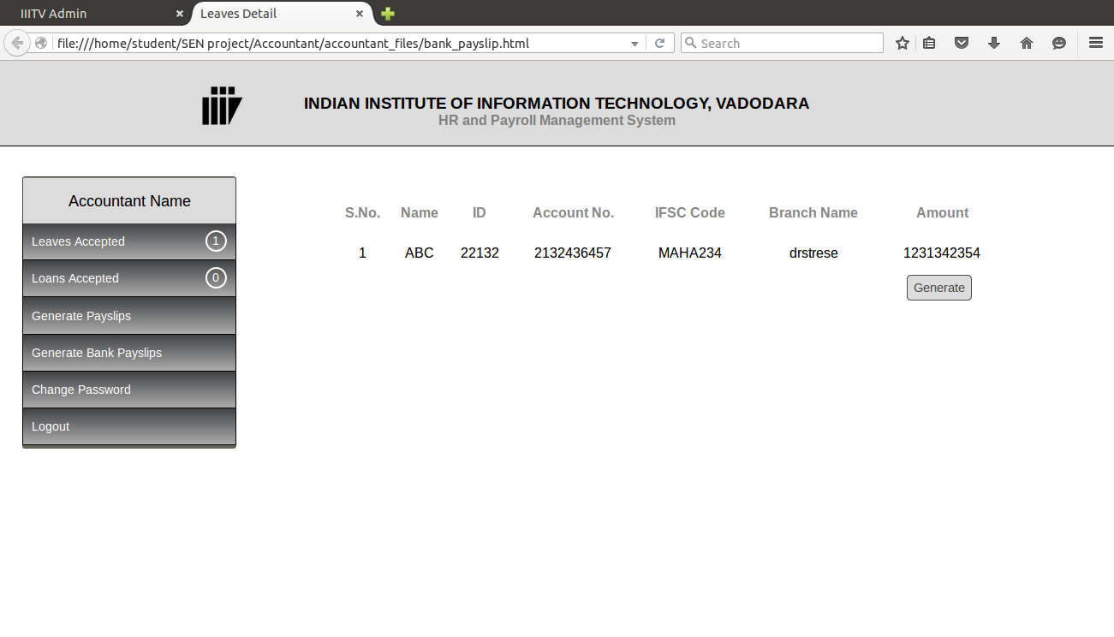
5.5 Change Password
By clicking on this option, the Accountant can change password. The Accountant need to provide current password for validation purpose if it is not correct, the system will not process the request to change the password, the new password will be updated and the Accountant can log in the system using new password. Accountant can enter his old password, then a new password and confirm the new password by entering it again. On clicking the 'Update Password' button, the password will be updated.

5.6 Logout
When the Accountant clicks on the logout option, he/she exits the system and can no longer access the system.

6. Employee
When an employee logs in the system, he can see his most recent payslip. He can also see his other previous payslips by selecting the month and year from the dropdown at the top of the page. By clicking on the 'Print' button on the bottom of the page, this page can be printed.
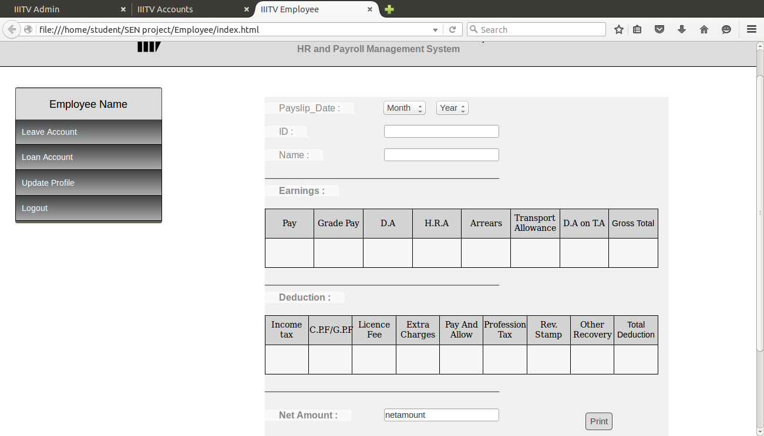
6.1 Leave Account
The user can check their leave status. User can keep a track of the number of leaves taken, the dates on which the leaves were taken and the category of the leave. User can also monitor the number of leaves still left in their leave account along with the category of leave remaining. User can also apply for a leave by filling out the leave application form which will be forwarded to the HR Admin for further processing. Once the leave is processed, the user will receive a notification for the same. The user can apply for the leave by selecting the type from the dropdown list, entering the from and to dates, total number of days and the reason for the leave. By clicking on the 'Apply for Leave' button, an application will be sent to the HR Admin with the above details for approval.
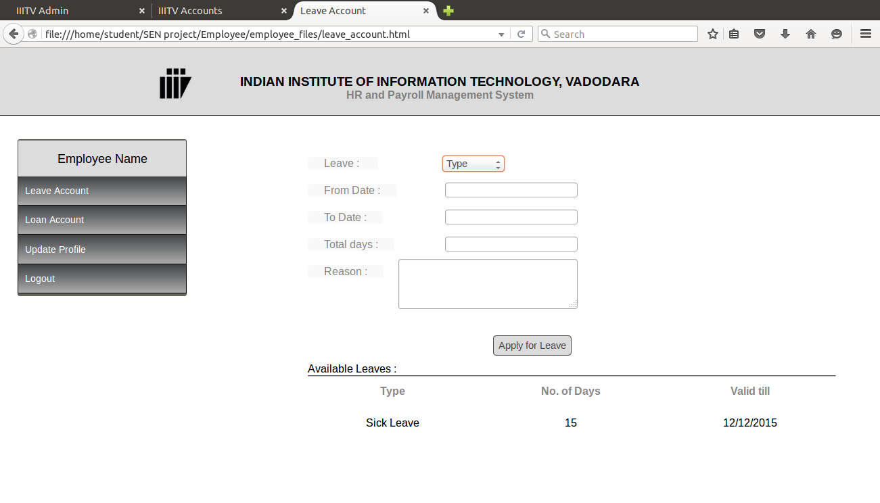
6.2 Loan Account
The user can check his loan status, if he/she has taken a loan from the institute. User can check the amount he/she has already paid and the dates that has paid the instalments. User can see the balance amount to be paid. The user can also apply for a loan by filling out the loan application form which will be forwarded to the HR Admin for further processing. Once the request for the loan is processed, the user will receive a notification form the same. The User can apply for loan by clicking on the 'Apply for Loan' button on the top of the page and filling out the form with loan type, amount and details of the loan. The Previous loans details can be seen just below the 'Apply for Loan' button.
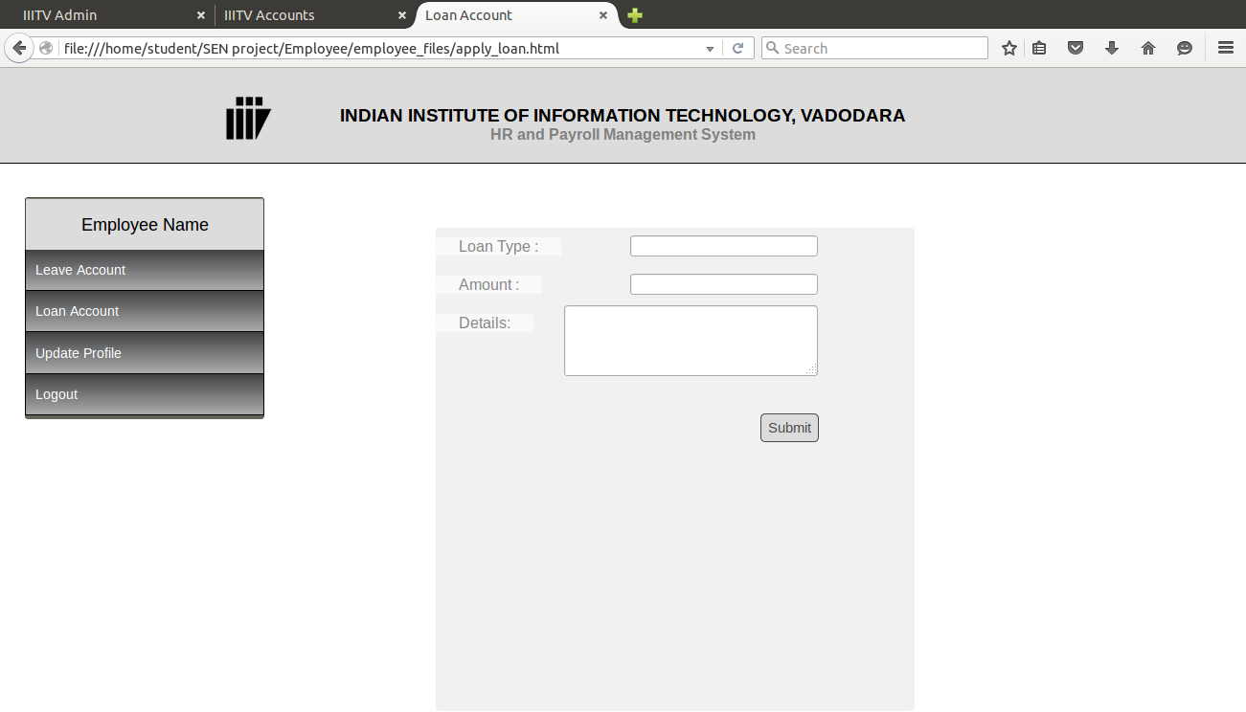
6.3 Update Profile
The user can edit the personal details that provided at the time of registration. User can edit his current address, phone, email id and the emergency contact details. User can also change password by entering current password. As soon as user changes his/her password, the new password will be updated and user can log in the system using new password. On clicking the 'Save' button, the updates will be saved.
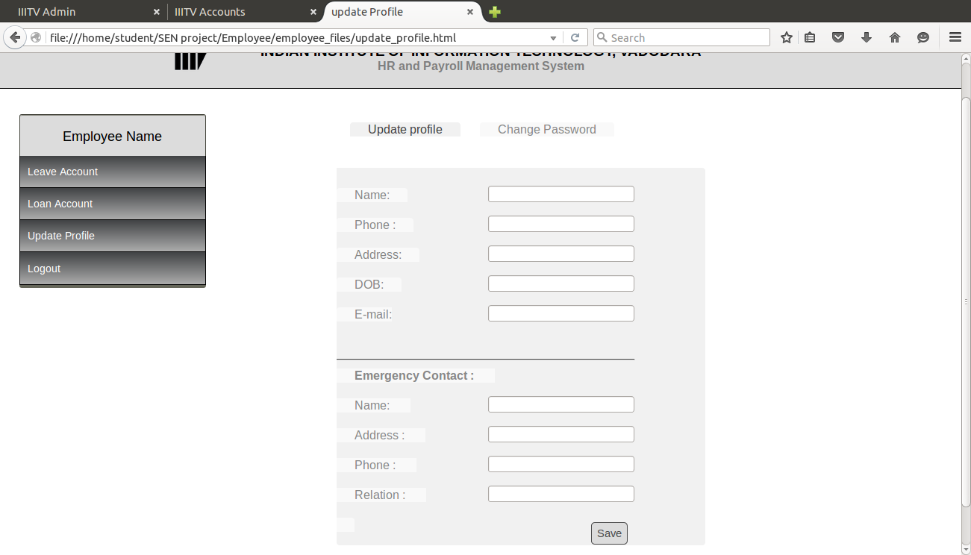
6.4 Logout
When the user clicks on the logout option, he/she exits the system. User can no longer access the system.

